Action | Keywords
Compare two strings. | StrComp
Convert strings. | StrConv
Convert to lowercase or uppercase. | Format, Lcase, Ucase
Create string of repeating character. | Space, String
Find length of a string. | Len
Format a string. | Format
Justify a string. | LSet, Rset
Manipulate strings. | InStr, ms-help://MS.EXCEL.DEV.12.1033/HV01204131.htm, LTrim, Mid, Right, RTrim, Trim
Set string comparison rules. | Option Compare
Work with ASCII and ANSI values. | Asc, Chr
''''''''''''''''''''''''''''''''''''''''''''''''''''''''''''''''''''''''''''''''''''''''''''''''''''''''''''''''''''''''''''
''''''''''''''''''''''''''''''''''''''''''''''''''''''''''''''''''''''''''''''''''''''''''''''''''''''''''''''''''''''''''''
' InStr
''''''''''''''''''''''''''''''''''''''''''''''''''''''''''''''''''''''''''''''''''''''''''''''''''''''''''''''''''''''''''''
''''''''''''''''''''''''''''''''''''''''''''''''''''''''''''''''''''''''''''''''''''''''''''''''''''''''''''''''''''''''''''

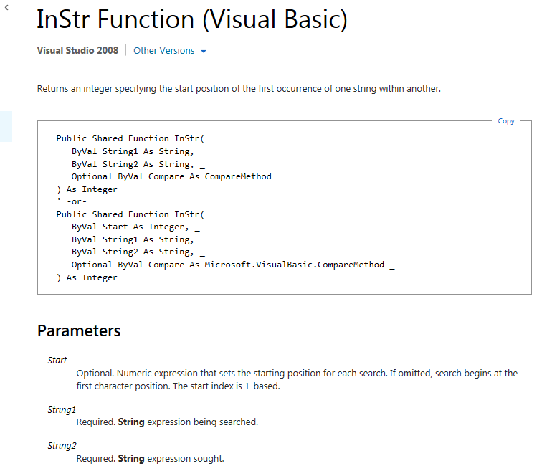
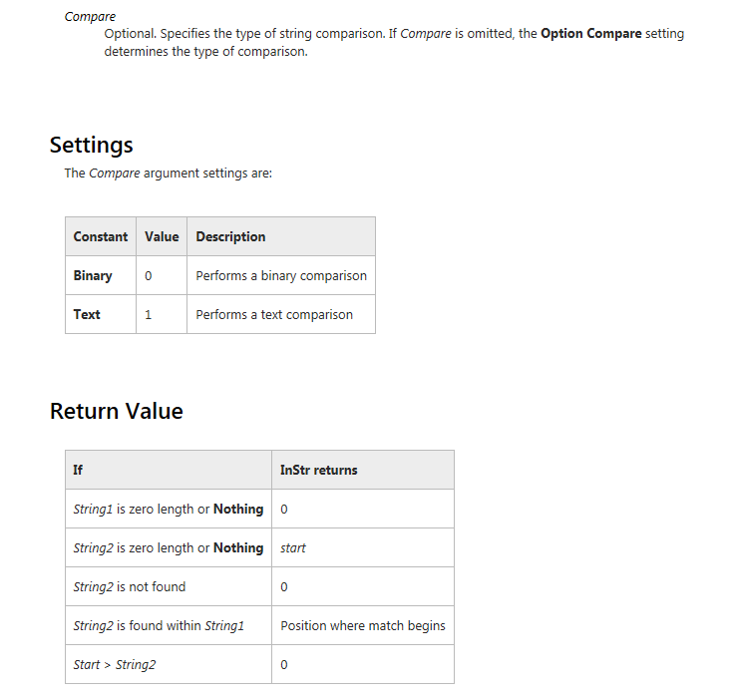
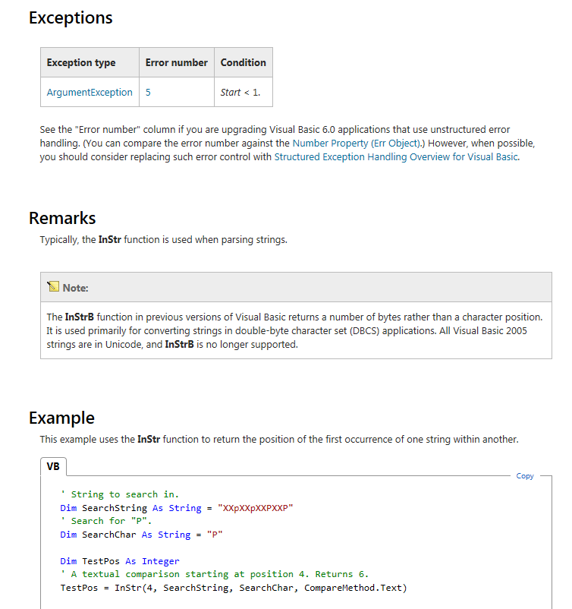

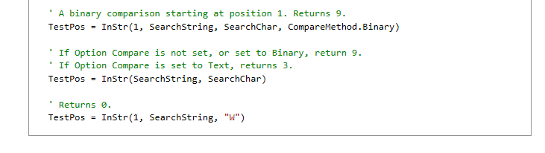
''''''''''''''''''''''''''''''''''''''''''''''''''''''''''''''''''''''''''''''''''''''''''''''''''''''''''''''''''''''''''''
''''''''''''''''''''''''''''''''''''''''''''''''''''''''''''''''''''''''''''''''''''''''''''''''''''''''''''''''''''''''''''
' Mid
''''''''''''''''''''''''''''''''''''''''''''''''''''''''''''''''''''''''''''''''''''''''''''''''''''''''''''''''''''''''''''
''''''''''''''''''''''''''''''''''''''''''''''''''''''''''''''''''''''''''''''''''''''''''''''''''''''''''''''''''''''''''''
